Sustainable Development Goals
Final Report
Introduction
This project aims to assess the sustainable development goals for all United Nation participating countries, evaluate the most advanced versus least advanced sustainable goal and the regions of where these goals are developing. The dataset will used from Kaggle which provides a primary and secondary dataset for the sustainable development goals of 2023 and years 2000-2022 separately. An additional dataset was cleaned from Kaggle to be added to the targeted dataset for the analysis, however, since it only focuses on SDG 7 (Energy), it will be added as meta data for each country.
The analysis will provide relationships and potential correlations between the values in the dataset, namely the SDG index and overall score, which are two desperate indicators for sustainable development in a country. Python will be used to make perform the exploratory data analysis in order to utilize the functions of the language and its vast applications to form extensive charts and descriptive analysis with the selected datasets.

Business Impact
Investigating this dataset will help allocate resources more effectively by identifying patterns and trends. This will allow for machine-learning based time-series forecasting which relies on the historical records and the performed prediction analysis. Exploring the data will also define where the strategies succeed in some regions and fail in other regions, giving an opportunity for more customized policies.
Cultivating these results will aid in providing a more thorough and specified action plan for countries to progress in their development goals depending on their own conditions and circumstances which will encourage cooperation and coordination between nations to achieve the shared objective for a more sustainable environment.

Data
Primary
File Name: sustainable_development_report_2023.csv
Description: Sustainable Development Report of 2023
Dataset Details: 167 rows & 21 columns
Size: 32 KB
Source: Kaggle- Dataset

Secondary
File Name: sdg_index_2000-2022.csv
Description: sustainability scores and performance on individual SDGs (2000-2022)
Dataset Details: 4141 rows & 21 columns
Size: 428 KB
Source: Kaggle- Dataset

Data Analysis & Computation
Data Cleaning (MS Excel)
- Unified the main indexes to contain the same categories (Country code, Country name, Region) in both datasets, primary and secondary
- Filled in the cells where the scores were left empty by calculating the average value of all 17 goals (overall score) and solving for the missing cell in the primary dataset
- Any rows that contain more than one empty cell were filled with (unavailable) in the primary dataset
- The “region” column was added to the secondary dataset and no other changes were done to this dataset
- Roughly 28% of the additional dataset were unavailable information due to the limited documentation of the country’s progress. It was then used as meta data to further explore the courtiers’ resources
Analysis (Python-Colab)
Analysis 1: Number of Rows and Columns - Excel
Merging the data together helped recognize which columns needed to be in the others dataset. This makes the total columns for the secondary data increase from 21 to 22 columns.
Analysis 2: Data Preparation - Python
The data was uploaded to the rive file and saved as a csv file, as mentioned previously, and imported into python as a data frame. Pandas and Matplotlib were used to perform the analysis functions on the data frame.
Analysis 3: Primary Dataset - 2023
The primary data represents the overall SDG score (average value of all 17 goals) for each participating country, which are 167 countries in total. Over 25 countries scored above 70 and around 20 countries scored above 80.
Analysis 4: Secondary Dataset – 2000-2022
The secondary data represents the SDG index scores for each country from years 2000 up to 2022. There were some countries that were not improving as anticipated over the years. For example, countries in regions like the Sub-Saharan Africa’s Ghana, Mozambique, and Mauritius, MENA’s Yemen, and Oceania’s Papua New Guinea, have been in a steady state for 22 years; neither improving nor reclining, struggling to achieve the sustainable goals and implement them into their respective nations.

Dashboard
Tableau was the tool used to visualize the data and form the obtained insights. The dashboard contains the UN and SDG logos, the world map showing each country's overall score up to 2023, the regions which contain the average SDG scores and filters to interact with the dashboard to find specific reports for a certain year or a range of years.
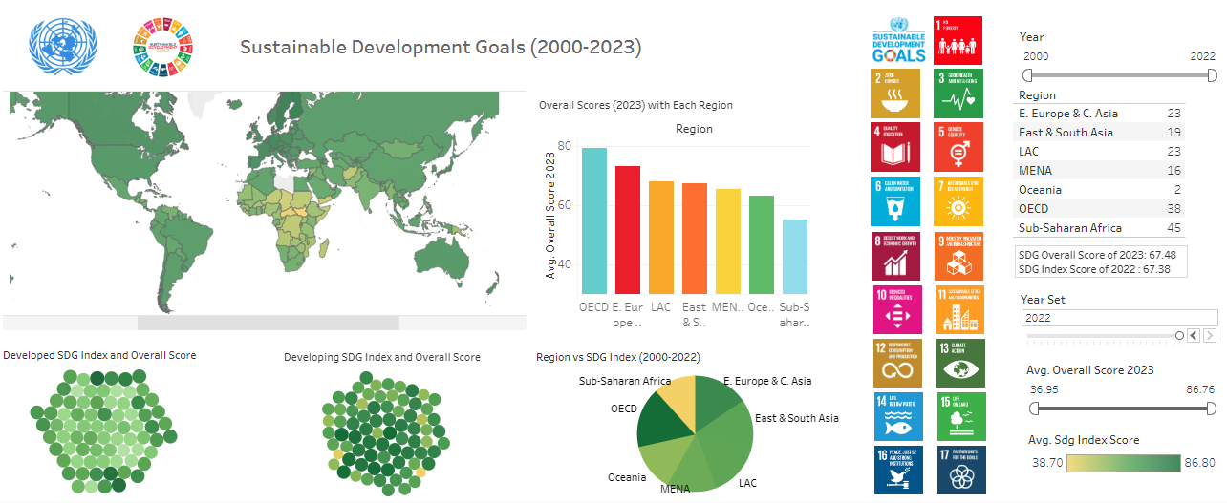
Figure 1: SDG Data Project Dashboard

Challenges
The project came with a series of challenges. The first challenge was to organize the data and accommodate the size of the data with the time frame that was provided. The next challenge was to perform EDA using python which required practicing and studying in order to create the notebook on Colab. Other challenges were faced during the data visualization phase on Tableau, where the 17 goals were not able to be visualized and summarized in the dashboard all at once.

Conclusion & Future Work
The analysis concludes that countries and regions such as Sub-Saharan Africa, MENA, and E. Europe C. Asia require more resources in order to progress in their sustainable development strategies. Several limitations were met during this project, the main limitation the large size of data that is associated with each sustainable goal and the given time frame in order to submit the project. Future studies should focus on each sustainable goal for all member countries of the UN to further identify the advantages and disadvantages of each country.

